Accessing the static methods via the reference variable instead of class name is the bad practice

Always use class name to access the static members

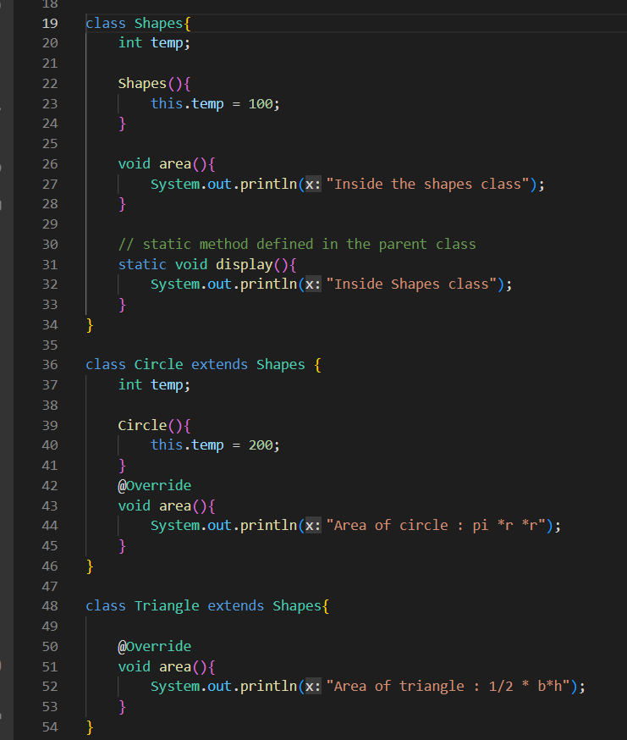

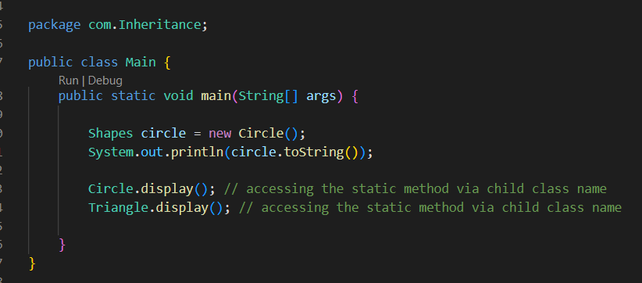

Here, display ( ) is defined as a static in parent class

And it is inherited by the child class

And we see display ( )is accessed also by using the child class name

**Rules**

1. Static methods can not be overridden
2. Static methods can be inherited and also can be accessed by the child class name after inheriting
3. Questions like this might be asked in interview